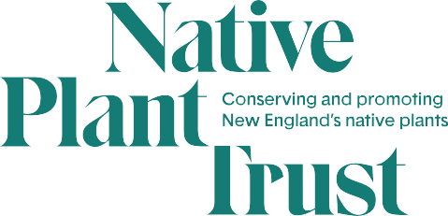

Chester B. Allen, Jr., Native Plant Propagation and Horticulture Internship

Nasami Farm Nursery
128 North Street
Whately, MA 01373
Native Plant Trust is the nation’s first plant conservation organization and the only one solely focused on New England’s native plants. We save native plants in the wild, grow them for gardens and restorations, and educate others on their value and use. Nasami Farm, our native plant nursery, produces plants for habitat restoration, wildlife landscapes, garden displays, and sale to the public at both the nursery and our 45-acre native plant botanic garden, Garden in the Woods, in Framingham, MA. Please visit www.NativePlantTrust.org.

Native Plant Nursery Propagation Internship

Number Available: 1 at Nasami Farm in Whately, MA
Application Deadline: Jan. 21, 2022
Duration: 6 months (28 weeks), starting late March/early April; 40-hour week with one weekend day required
Hours and Compensation: 40 hrs/week at $14.50/hr
Contact: Alexis Doshas, Nursery Manager
Telephone: 413-397-9922
Fax: 413-397-9944
Email: adoshas@NativePlantTrust.org
Interns gain hands-on experience identifying, propagating, and cultivating New England native plants in a nursery setting. As part of this experience, interns assist in many facets of nursery operations, including propagation of numerous species, retail plant sales, seed collection and processing, record keeping, and public information duties. This is an opportunity to gain valuable skills by learning from staff, coordinating volunteers, leading projects, and participating in the development of an expanding nursery. Interns will complete a special project of their interest, participate in educational activities, network with professionals, and attend field trips. Provides entry into both native plant studies and nursery management.

Interns are covered by worker’s compensation and receive paid sick time per Massachusetts law. Native Plant Trust does not provide health insurance or vacation benefits to seasonal interns. Proof of vaccination and booster for COVID 19 are required. Benefits include a wide range of optional education classes and field trips through Native Plant Trust's extensive education program and with organizations that share our mission.
Candidates should possess some botanical understanding, familiarity with horticultural practices, an interest in native plants of the Northeast, excellent communication skills, and a strong desire to learn.

Native Plant Trust is an equal opportunity employer and values diversity. All employment is decided on
the basis of qualifications, merit, and business need.

To apply, email or mail a resume, cover letter, and a list of three references to:

Alexis Doshas, Nursery Manager
Native Plant Trust at Nasami Farm
128 North Street
Whately, MA 01373
adoshas@NativePlantTrust.org

Applications are due January 21, 2022.

